***ANUDIP FOUNDATION***

A Project Report on

**AI Based Interview Simulator**

By

Batch: ANP-D0453

Student ID: AF0477457

Name : Haripriya Kota

**Under the Guidance of**

Mrs. Rajshri Chandrabhan Thete

The AI-Based Interview Simulator is a web-based application designed to help job seekers prepare for technical and HR interviews through an AI-powered interactive platform. It generates realistic interview questions, evaluates user responses, and provides feedback based on AI-driven analysis. The system mimics real-world interview scenarios to enhance candidates' confidence, communication skills, and subject knowledge.

**Entities:**

**❖ User**

**❖ Interview Session**

**❖ Question**

**❖ Answer**

**❖ Response**

**❖ Report**

**ATTRIBUTES OF ENTITIES:**

**1. User Attributes:**

**●** User_id (primary key)

● Name

● Mobile_No (Unique)

● Email (Unique)

● Password

● Experience_level

**2. Interview_Session Attributes:**

**●** Session_Id (primary key)

● User_Id (foreign key)

● Schedule_Date

● Start_Time

● End_Time

**3. Question Attributes:**

**●** Q_id (primary key)

● Question_Text

● Difficulty_level

● Session_Id (foreign key)

**4. Answer Attributes:**

**●** Answer_Id (primary key)

● Q_ID (foreign key)

● Answer_Text

● Question_Text

**5. Response Attributes:**

**●** Response_Id (primary key)

● User_Id (foreign key)

● Q_Id (foreign key)

● Response_Text

● Correct_Answer

● AI_Score

● AI_Feedback

**6. Report Attributes:**

**●** Report_Id (primary key)

● Session_Id (foreign key)

● Response_Id (foreign key)

● Q_ID (foreign key)

● User_Id (foreign key)

● Improvement_Suggestions

**ENTITY RELATIONSHIP DIAGRAM – AI Based Interview Simulator**

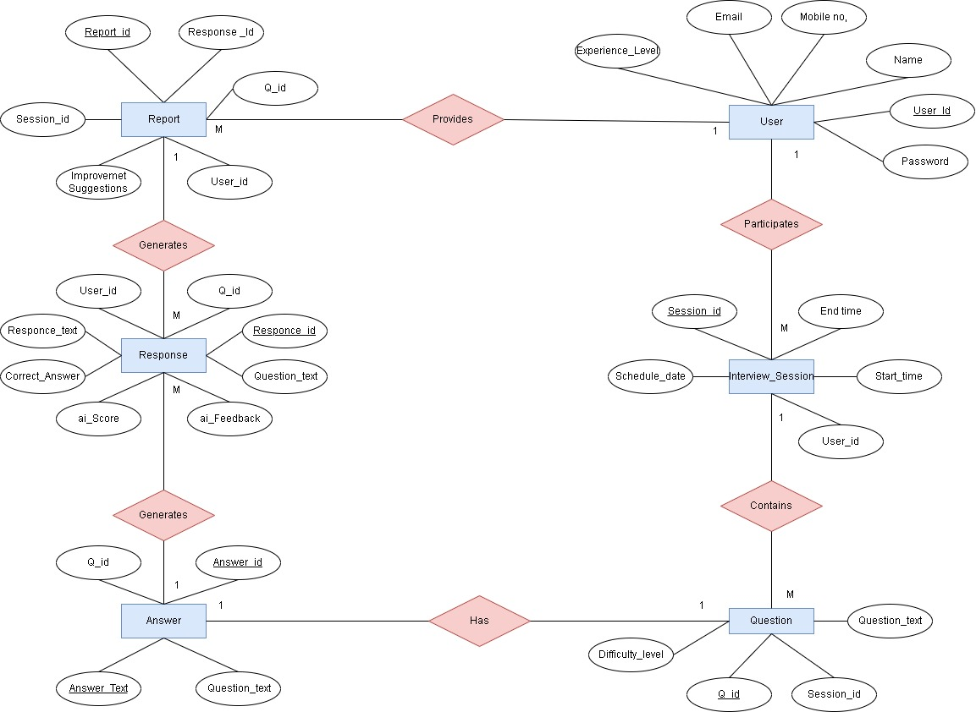

**Database Creation :**

CREATE DATABASE InterviewSimulator;

USE InterviewSimulator;

**-- User Table**

CREATE TABLE User (

User_Id INT NOT NULL AUTO_INCREMENT,

Name VARCHAR(100) NOT NULL,

Email VARCHAR(100) NOT NULL UNIQUE,

Mobile_No VARCHAR(15) NOT NULL UNIQUE,

Password VARCHAR(255) NOT NULL,

Experience_Level VARCHAR(50),

PRIMARY KEY (User_Id)

);

-- **Interview Session Table**

CREATE TABLE Interview_Session (

Session_Id INT NOT NULL AUTO_INCREMENT,

User_Id INT,

Schedule_Date DATE NOT NULL,

Start_Time TIME NOT NULL,

End_Time TIME NOT NULL,

PRIMARY KEY (Session_Id),

FOREIGN KEY (User_Id) REFERENCES User(User_Id) ON DELETE SET NULL

);

-- **Question Table**

CREATE TABLE Question (

Q_Id INT NOT NULL AUTO_INCREMENT,

Question_Text TEXT NOT NULL,

Difficulty_Level VARCHAR(50),

Session_Id INT,

PRIMARY KEY (Q_Id),

FOREIGN KEY (Session_Id) REFERENCES Interview_Session(Session_Id) ON DELETE SET NULL

);

-- **Answer Table**

CREATE TABLE Answer (

Answer_Id INT NOT NULL AUTO_INCREMENT,

Q_Id INT UNIQUE,

Answer_Text TEXT NOT NULL,

Question_Text TEXT NOT NULL,

PRIMARY KEY (Answer_Id),

FOREIGN KEY (Q_Id) REFERENCES Question(Q_Id) ON DELETE CASCADE

);

-- **Response Table**

CREATE TABLE Response (

Response_Id INT NOT NULL AUTO_INCREMENT,

User_Id INT,

Q_Id INT,

Response_Text TEXT NOT NULL,

Correct_Answer TEXT NOT NULL,

AI_Score DECIMAL(5,2),

AI_Feedback TEXT,

PRIMARY KEY (Response_Id),

FOREIGN KEY (User_Id) REFERENCES User(User_Id) ON DELETE SET NULL,

FOREIGN KEY (Q_Id) REFERENCES Question(Q_Id) ON DELETE CASCADE

);

**-- Report Table**

CREATE TABLE Report (

Report_Id INT NOT NULL AUTO_INCREMENT,

Session_Id INT,

Response_Id INT,

Q_Id INT,

User_Id INT,

Improvement_Suggestions TEXT,

PRIMARY KEY (Report_Id),

FOREIGN KEY (Session_Id) REFERENCES Interview_Session(Session_Id) ON DELETE SET NULL,

FOREIGN KEY (Response_Id) REFERENCES Response(Response_Id) ON DELETE CASCADE,

FOREIGN KEY (Q_Id) REFERENCES Question(Q_Id) ON DELETE CASCADE,

FOREIGN KEY (User_Id) REFERENCES User(User_Id) ON DELETE SET NULL

);

**Output :**

mysql> use interviewSimulator;

Database changed

mysql> show tables;

+------------------------------+

| Tables_in_interviewsimulator |

+------------------------------+

| answer |

| interview_session |

| question |

| report |

| response |

| user |

+------------------------------+

6 rows in set (0.17 sec)

mysql> desc answer;

+---------------+------+------+-----+---------+----------------+

| Field | Type | Null | Key | Default | Extra |

+---------------+------+------+-----+---------+----------------+

| Answer_Id | int | NO | PRI | NULL | auto_increment |

| Q_Id | int | YES | UNI | NULL | |

| Answer_Text | text | NO | | NULL | |

| Question_Text | text | NO | | NULL | |

+---------------+------+------+-----+---------+----------------+

4 rows in set (0.07 sec)

mysql> desc interview_session;

+---------------+------+------+-----+---------+----------------+

| Field | Type | Null | Key | Default | Extra |

+---------------+------+------+-----+---------+----------------+

| Session_Id | int | NO | PRI | NULL | auto_increment |

| User_Id | int | YES | MUL | NULL | |

| Schedule_Date | date | NO | | NULL | |

| Start_Time | time | NO | | NULL | |

| End_Time | time | NO | | NULL | |

+---------------+------+------+-----+---------+----------------+

5 rows in set (0.00 sec)

mysql> desc question;

+------------------+-------------+------+-----+---------+----------------+

| Field | Type | Null | Key | Default | Extra |

+------------------+-------------+------+-----+---------+----------------+

| Q_Id | int | NO | PRI | NULL | auto_increment |

| Question_Text | text | NO | | NULL | |

| Difficulty_Level | varchar(50) | YES | | NULL | |

| Session_Id | int | YES | MUL | NULL | |

+------------------+-------------+------+-----+---------+----------------+

4 rows in set (0.00 sec)

mysql> desc report;

+-------------------------+------+------+-----+---------+----------------+

| Field | Type | Null | Key | Default | Extra |

+-------------------------+------+------+-----+---------+----------------+

| Report_Id | int | NO | PRI | NULL | auto_increment |

| Session_Id | int | YES | MUL | NULL | |

| Response_Id | int | YES | MUL | NULL | |

| Q_Id | int | YES | MUL | NULL | |

| User_Id | int | YES | MUL | NULL | |

| Improvement_Suggestions | text | YES | | NULL | |

+-------------------------+------+------+-----+---------+----------------+

6 rows in set (0.00 sec)

mysql> desc response;

+----------------+--------------+------+-----+---------+----------------+

| Field | Type | Null | Key | Default | Extra |

+----------------+--------------+------+-----+---------+----------------+

| Response_Id | int | NO | PRI | NULL | auto_increment |

| User_Id | int | YES | MUL | NULL | |

| Q_Id | int | YES | MUL | NULL | |

| Response_Text | text | NO | | NULL | |

| Correct_Answer | text | NO | | NULL | |

| AI_Score | decimal(5,2) | YES | | NULL | |

| AI_Feedback | text | YES | | NULL | |

+----------------+--------------+------+-----+---------+----------------+

7 rows in set (0.00 sec)

mysql> desc User;

+------------------+--------------+------+-----+---------+----------------+

| Field | Type | Null | Key | Default | Extra |

+------------------+--------------+------+-----+---------+----------------+

| User_Id | int | NO | PRI | NULL | auto_increment |

| Name | varchar(100) | NO | | NULL | |

| Email | varchar(100) | NO | UNI | NULL | |

| Mobile_No | varchar(15) | NO | UNI | NULL | |

| Password | varchar(255) | NO | | NULL | |

| Experience_Level | varchar(50) | YES | | NULL | |

+------------------+--------------+------+-----+---------+----------------+

6 rows in set (0.00 sec)